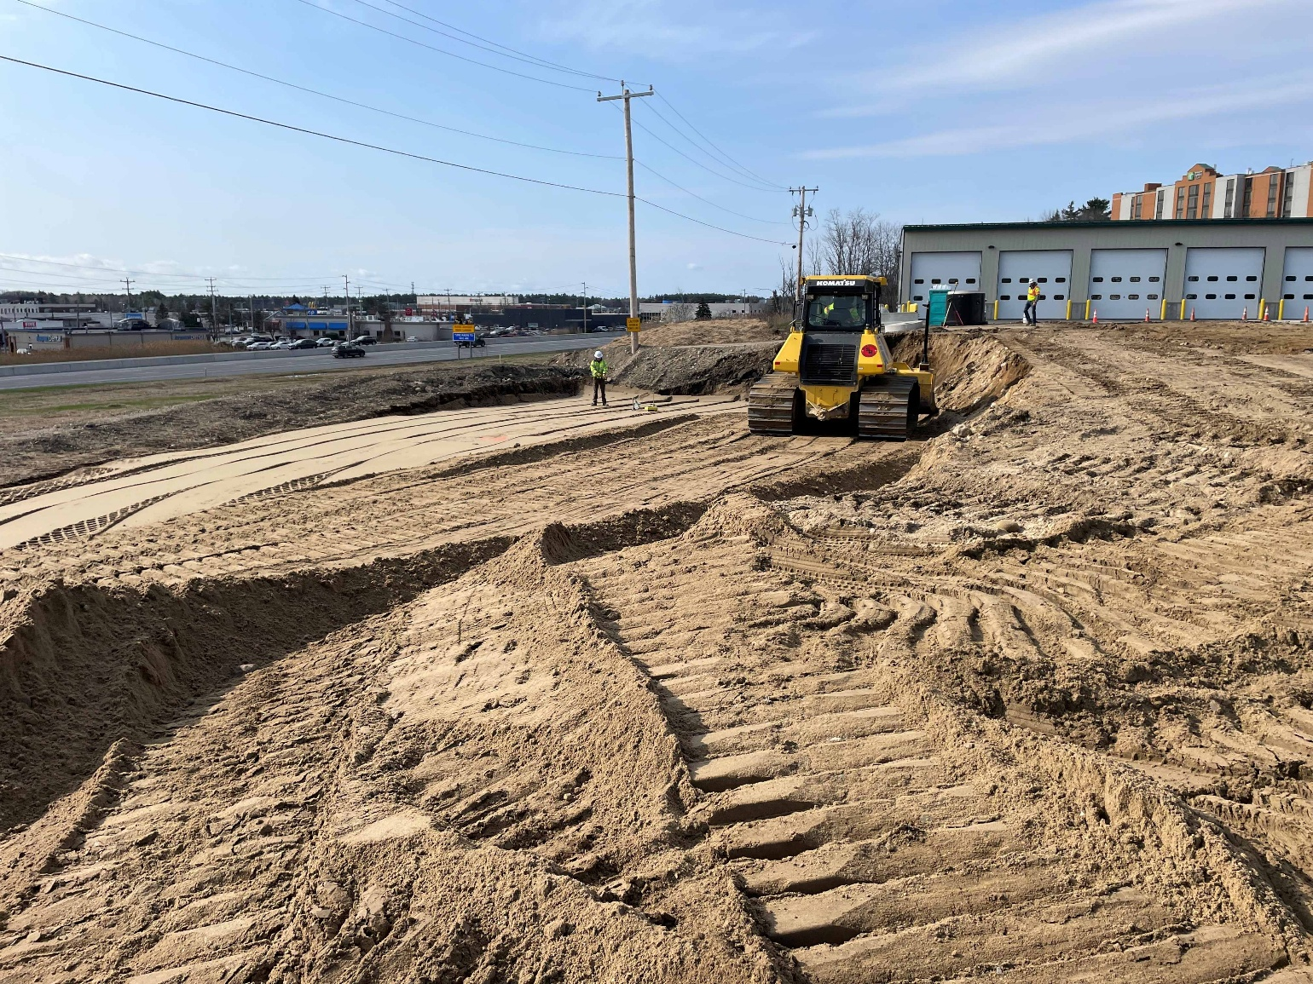
A bulldozer is used to spread borrow and gravels that will be the base for the new foundation.

Contractor: Benchmark Construction Bid Amount: $3,977,392.00

Percent Complete last approved pay estimate: 3.3 %

Project Schedule: Completion date December 18, 2026.

Project Scope: The work consists of the construction of an approximate 6,000 square foot wood-framed building consisting of offices, a crew room with kitchenette, locker and toilet rooms. Including, but is not necessarily limited to, the building structure, mechanical, electrical, and plumbing, as well as all site work, grading, pavement, lighting, utilities, and all other work incidental thereto in accordance with the Plans and Specifications.

Contractor Schedule: The contractor is working on the site work, utility coordination, and foundation prep work as the weather improves. The foundation crew is anticipated to show up in May to start that phase of the project. This should take all of 2026 to complete this project if there are no weather or material delivery delays.

