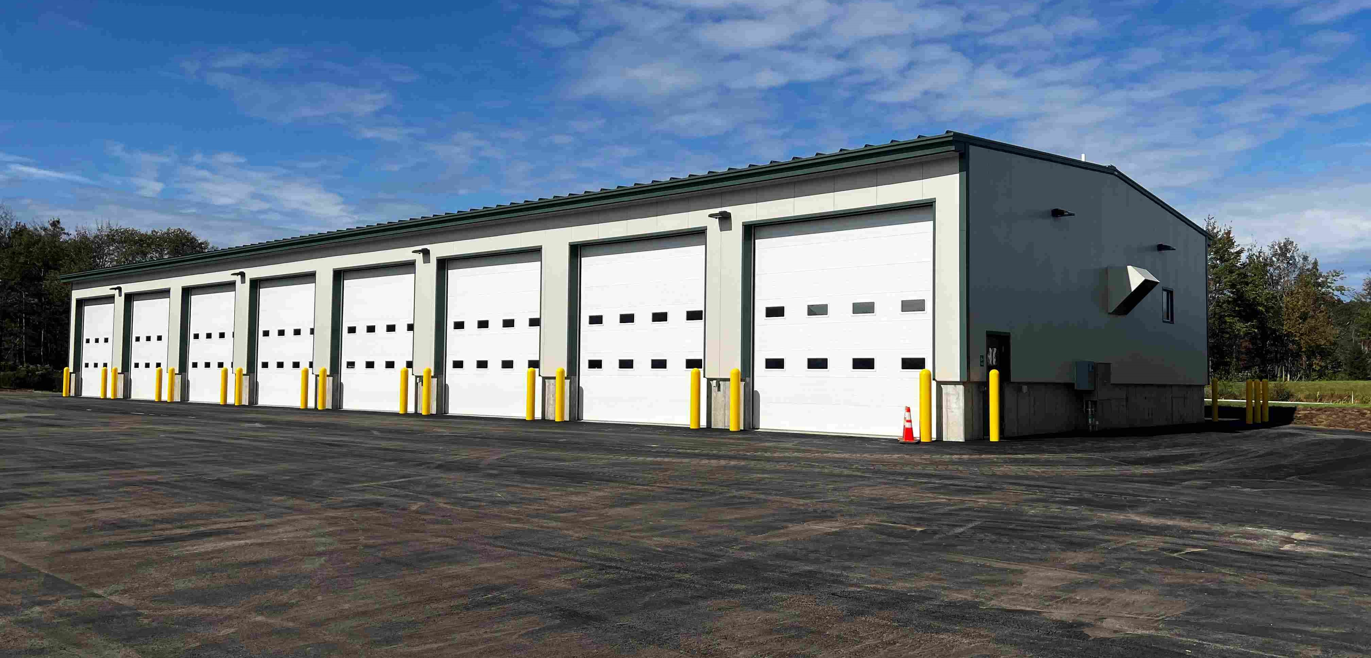
Recently completed surface paving and site work at the Litchfield facility.
Contractor: Sheridan Construction Corporation Bid Amount: $2,651,753.27

Percent Complete last approved pay estimate: 83.6%

Project Schedule: Completion date November 17, 2023

Project Scope: Construction of an approximate 8,800 square foot pre-engineered building consisting of eight (8) vehicle storage garage bays, all site work, paving, lighting, generator removal, generator installation, relocating propane tanks, floor slab and foundation removal, maintaining facility operation areas, power utility services and site utilities. This work also includes the emergency building repairs at Auburn Maintenance facility. The building is receiving structural, electrical, and cosmetic repairs after the wing plow made contact with the building during a winter storm.

Contractor Schedule: The building is substantially complete. Crews have started all mechanical and electrical systems. All site grading, drainage, and paving has been completed at this time. The design and engineering team will be preparing preliminary punch lists of the completed building except for the generator and related systems. The generator is on backorder and not scheduled to arrive onsite until late October.

