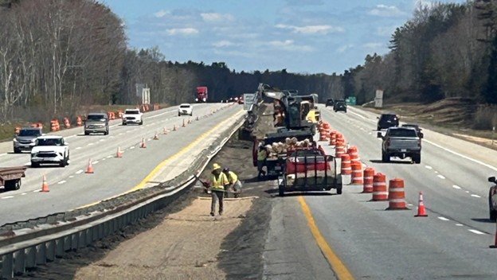

The Contractor has completed guardrail adjustments and is working on median restoration.

Contractor: Pike Industries Bid Amount: $7,279,588.50

Percent Complete last approved pay estimate: 9.4 %

Project Schedule: Completion date November 21, 2026

Project Scope: The pavement rehabilitation work consists of milling and paving three travel lanes and the median and outside shoulders for both northbound and southbound approaches. There are short sections where the shoulder pavement will be reconstructed. Excess material in the median will be removed and catch basins shall be cleaned to restore proper drainage. Noted catch basin tops will be replaced, and concrete aprons will be installed around the basins where required. Guardrail height
will be adjusted as necessary, with damaged sections of guardrail being replaced where it is needed. Pavement markings, maintenance of traffic and all other work incidental thereto will be completed in accordance with the Plans and Specifications.

Contractor Schedule: The contractor completed guardrail adjustments and is working on median restoration efforts. The contractor is scheduled to begin pavement milling operation in mid-May.

