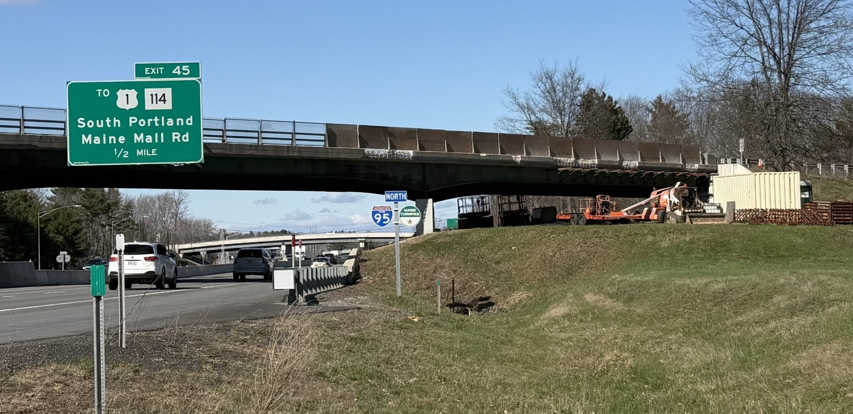

Looking at the I-295 Underpass, the contractor is working on bridge fascia structural concrete repairs.

Contractor: CPM Constructors, Inc. Bid Amount: $2,356,493.40

Percent Complete last approved pay estimate: 4.0 %

Project Schedule: Completion date November 20, 2026.

Project Scope: The work consists of bridge repairs at three locations; Broadturn Road Underpass, I-295 Southbound Underpass and Maine Mall Road Underpass. The work generally consists of milling and paving the bridge and local road approaches, concrete haunch removal, concrete patch repair to the existing deck fascia and substructure, concrete pier repairs, cleaning and painting of existing bearings, replacing bearings, joint repairs, and concrete sealing. The work also includes maintenance of traffic, and all other work is incidental thereto in accordance with the Plans and Specifications.

Contractor Schedule: CPM is currently working on removing deteriorated concrete from I-295 Underpass bridge fascia and abutments as structural concrete repairs are in progress. Bridge repair work will continue at three bridge locations under this contract until the completion date in November.

